Warrant Officer Career Opportunities  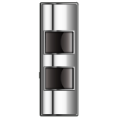  Active Duty Quartermaster Soldiers transitioning to the Reserve Component should take advantage of the WOC Program. |  |  |  |  |  | 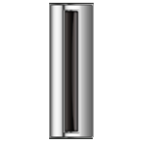  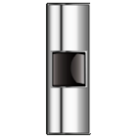  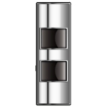  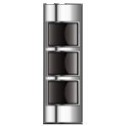  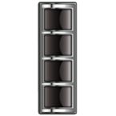
There are two steps to determine if you are qualified.
(Note: You must meet all requirements in Step 1 before you can proceed to Step 2)
STEP 1: Meet the following Army Administrative requirements (Check the block if you meet).
U.S. Citizenship |  | High School Graduate or GED |  |  | GT Score 110 or higher
Secret or interim clearance |  | Pass the APFT and meet height and weight standards |  |  | Pass the Appointment Physical
Be less than 46 years old (waiverable) |  | Have no more than 12 months remaining on their Enlisted contract
STEP 2: Meet the Quartermaster Requirements listed on the below link.
(If you meet the listed requirements please proceed to Step 3)
http://www.usarec.army.mil/hq/warrant/prerequ/WO920A.shtml  (920A) Property Accounting Technician - MOS 68J, 92Y |  |  | http://www.usarec.army.mil/hq/warrant/prerequ/WO920B.shtml  (920B) Supply Systems Technician - MOS 92A
http://www.usarec.army.mil/hq/warrant/prerequ/WO921A.shtml  (921A) Airdrop Systems Technician - MOS 92R |  |  | http://www.usarec.army.mil/hq/warrant/prerequ/WO922A.shtml  (922A) Food Service Technician - MOS 92G, 68M
http://www.usarec.army.mil/hq/warrant/prerequ/WO923A.shtml
(923A) Petroleum Systems Technician - MOS 92F, 92L, 92W
STEP 3: Contact your Reserve Component Career Counselor (RCCC) Representative at your local installation.
- U.S. Army Reserves Regional Recruiters can be found on the following website:
http://stayarmyreserve.army.mil/region_contact.htm
- Army National Guard Strength Managers for each state can be found on the following website:
http://www.nationalguard.com/careers/become-a-warrant-officer/recruiter-contact
- Quartermaster
http://www.quartermaster.army.mil/

If you cannot locate your Installation Reserve Component Career Counselor or have any questions please contact the Quartermaster Corps Warrant Officer Personnel Developers at
usarmy.lee.tradoc.list.qm-warrant-personnel-dev@mail.mil
Tips and Information: | Soldiers can easily improve their GT scores by enrolling in the FAST (Functional Academic Skills Training) program at their local Educational Office, or use the ASVAB study guide websites below:
https://www.goarmyed.com/public/public_goarmyed-education_centers.aspx |  |  |  | http://asvab-studyguide.com/
It is important to obtain letters of recommendation from your Commander and a Senior Warrant Officer in the career field you are applying before you separate. Information pertaining to format can be found at: http://www.usarec.army.mil/hq/warrant/download/LORSample2009.pdf
12 years or more of Active Federal service is not a disqualifier.

