REPLY TO

ATTENTION OF

OFFICE SYMBOL DATE

MEMORANDUM FOR RECORD

SUBJECT: X Brigade Food Service Program Standard Operating Procedures

1. PURPOSE. To establish duties, responsibilities, and procedures for all assigned and attached units of the X Brigade for the efficient operation of the brigade Food Service Program, and brigade operated dining facilities. This SOP is intended to assist commanders at all levels in providing the highest quality food service to X Brigade Soldiers and civilians. The overall intent is to sustain DFAC operations while supporting training exercises and mission requirements.

2. APPLICATION. This Standard Operating Procedure (SOP) supersedes previous guidance and applies to all personnel assigned or attached to the X Brigade.

3. DISCUSSION. The X Brigade Food Service Program is based on Department of the Army policy directives such as those set forth in AR 30-22, and DA PAM 30-22, and strives to provide the highest quality food service possible in garrison and field operations while ensuring the effective and efficient use of personnel, material, and resources. The policies and procedures outlined in this SOP establish standardized guidance in food service related matters. Direct questions regarding this SOP to the Brigade Food Service Technician or Chief Food Operations NCO.

4. FORMAT. The SOP in the attached Appendix contains four sections: (1) Responsibilities; (2) Field Feeding Operations; (3) Garrison Operations; and (4) Templates.

5. The POC for this SOP is the X Brigade Food Service Technician, CW2 Richard Smart at phone-number, and email: first.lastname@us.army.mil.

BRIGADE COMMANDER

COL, AR

Commanding

DISTRIBUTION:

ALL UNITS of X Brigade, X Division

BN S-4, X Brigade, X Division

BDE S4, X Brigade, X Division

**Appendix**

**Section 1: Responsibilities**

1. Organizational Commanders:

a. Commanders are responsible for ensuring that all 92G Food Service Personnel are supporting the Dining Facility (DFAC) and not assigned duties outside the DFAC. This is necessary to ensure sufficient personnel are present for duty and to prevent 92Gs on duty in the DFAC from being forced to endure excessive workloads and hours. The quality of food service at the Dining Facility directly impacts the morale of all supported personnel, and overworked food service personnel will not provide the highest quality food service possible. In addition, duty in the DFAC is inherently dangerous and food service personnel should have the same rest and recovery periods as Soldiers in other Military Occupational Specialty (MOS).

b. Ensure the policies and procedures outlined in this SOP are implemented and maintained.

2. Brigade Food Service Technician / Chief Food Operations NCO:

a. Serve as the technical expert and advises the Brigade Commander on all aspects of garrison food service and unit field feeding operations, matters relating directly to dining facility management, food preparation, equipment, facilities, training, and personnel.

b. Ensure all food service operations under brigade control operate within the scope of AR 30-22 and DA PAM 30-22.

c. Provide technical advice and make recommendations to the appropriate commanders on methods and procedures for improving overall food service support.

d. Visit dining facilities daily and conduct monthly evaluations to identify deficiencies and provide corrective measures to improve the overall operations.

e. Provide guidance and assistance in preparing reports, requests, and other documentation needed to improve operations.

f. Assist the DFAC Manager in developing MOS related training for the cooks assigned to the DFAC.

g. Conduct evaluations of each unit’s field feeding equipment in conjunction with the unit commander’s monthly 10% inventory.

h. Complete an evaluation of the X Brigade DFAC at least once per month, and provide a Food Service Action plan in accordance (IAW) with DA PAM 30-22, par 3-8, that will serve as a review of the DFAC account, to the X Brigade Commander once per quarter.

i. Supervise the training and evaluation of all assigned food service personnel within the brigade.

j. Conduct meetings with brigade food service personnel twice per month IOT coordinate training, food service support, and other requirements.

k. The X Brigade Food Service Technician serves as the Rater for the Chief Food Operations NCO (MSG assigned to the X Brigade S4).

3. Senior Food Operations Management NCO (Dining Facility Manager):

a. Responsible for the day-to-day operation of the DFAC and controls every aspect of food ordering, rations, accountability, meal production and serving, sanitation, administrative duties, and personnel welfare.

b. Schedule all food service personnel OPCON to the DFAC for duty. Produce the work schedule by the 15th of each month for the following month, unless shortcoming changes occur.

c. Maintain responsibility and accountability of all equipment and ensure that proper supply procedures are followed.

d. Determine the menu and direct the preparation of production schedules for the FSO approval and signature.

e. Conduct weekly meetings with the food service personnel from each unit within the DFAC to discuss upcoming/current training, functions, and special meals.

f. Organize the Food Service Specialist / Food Operations NCO of the Quarter boards.

g. Supervise the accountability of all rations and monies.

h. Work with the Brigade Food Service Technician / Chief Food Service Supervisor / Food Service Officer, unit commanders and First Sergeants to resolve administrative and disciplinary issues with food service personnel.

i. Establish internal DFAC policies and SOPs for the performance of assigned and implied missions.

j. Provide Letters of Continuity / Performance for all X Brigade Battalion Food Operations Management NCOs (FOMNs; Forward Support Company food service NCOs) working in the DFAC.

k. Conduct quarterly enlisted advisory DFAC council meetings.

4. Food Service Officer (FSO):

a. Perform administrative duties as specified in AR 30-22. More specifically:

1. Monitor DFAC operations to ensure regulatory compliance.

(2) Monitor DFAC accounting procedures and administrative records to ensure compliance with regulatory guidance. Emplace operational controls to ensure that the DFAC account is not overspent at the end of the fiscal year.

(3) Perform daily cash turn-ins, monthly high dollar subsistence inventory, semiannual requisitioning and receiving reviews, and semiannual physical security reviews.

b. Act as the Brigade Support Battalion commander’s representative in all matters concerning the DFAC.

c. Enforce measures to conserve, safeguard, and account for all subsistence supplies issued, prepared, and served per AR 30-22 and TM 4-41.11.

d. Ensure DFAC operations conform to the highest attainable standards in food preparation, service, atmosphere, and sanitation.

e. Responsible for the receipt, issue, use, turn-in, and storage of all cashbooks, and monies from the DFAC.

f. Supervise all administrative and personnel actions for X Brigade Food Service Personnel(92G) working in the X Brigade DFAC. All personnel actions are accomplished through the 92G Soldier’s parent unit, but the FSO ensures that the DFAC chain of command completes their portion of all personnel actions including Soldier counseling, recommendations for boards and promotions, NCOERs, leave and pass requests, and any other actions that affect the Soldier’s ability to perform assigned duties within the DFAC.

g. Develop and sign a Memorandum of Agreement (MOA) or Memorandum of Understanding (MOU) outlining areas of support and responsibilities for units supported by the X Brigade Dining Facility, or other units that have X Brigade 92G Food Service Personnel working in their dining facilities. The MOA will be signed by Commanders of each respective unit; the MOU will be signed by the X Brigade Commander.

5. Food Operations Management NCO (FOMN) (FSC/Battalion food service sergeant):

a. Responsible for the accountability and maintenance of MTOE equipment in accordance with the X Brigade Field Feeding equipment accountability procedures. Must conduct prior coordination with the DFAC Manager for time and personnel to perform maintenance and work in unit TOE rooms.

b. Ensure that the Soldiers from their unit maintain current qualification on the Army Physical Fitness Test (APFT), Common Task Training (CTT), weapon qualification, annual training requirements, and all deployment criteria.

c. Serve as the link between their unit and the DFAC for administrative matters, personnel actions, and other unit activities that concern food service personnel. Ensure that all of these matters/actions are routed through the DFAC manager, and through the parent unit chain of command IAW the signed MOA/MOU. .

d. Coordinate all unit and Soldier training requirements through the manager and DFAC training NCO for inclusion in the DFAC work schedule. However, this does not replace the requirement for each unit to submit scheduled training in memorandum format three weeks in advance.

6. General:

* 1. OPCON Relationship:

(1) When the X Brigade Dining Facility is utilized as a consolidated operation with other brigade, battalion, or other elements being supported and providing their food service personnel, it is understood and mutually agreed that all assigned food service personnel of X Brigade, will be under the operational control of the X Brigade DFAC manager. A Memorandum of Agreement between X Brigade and consolidated units will address the OPCON relationship for food service personnel as well.

(2) All food service personnel from the X Brigade will perform MOS duties in the DFAC based on the work schedule published by the DFAC Manager and reviewed by the Chief Food Operations NCO. During the DFACs normal duty hours, food service personnel should not be directed to perform duties outside of the DFAC by their parent unit. In order to ensure there are sufficient food service personnel on duty at the DFAC to sustain continuing operations, units will not direct their Soldiers to leave the DFAC without prior coordination with the DFAC manager.

(3) Outside of the normal DFAC duty hours, food service personnel will not perform excessive amounts of work for their parent unit. Food service personnel will perform TOE equipment maintenance, physical training, cleaning and maintenance of their living areas, scheduled training, and corrective training/extra duty as appropriate by each parent unit between scheduled shifts at the DFAC. In the event that a parent unit wishes to task a 92G Soldier(s) with duties outside of the DFAC or if the outside duties interfere with the 92G Soldier(s) normal shift schedule, the Chief Food Operations NCO, Brigade Food Service Technician, and/or the Food Service Officer will coordinate with the Soldier(s) parent unit chain of command. This agreement is intended to empower the DFAC Manager with the authority to prevent parent units from removing organic food service personnel (92Gs) from scheduled shifts in the DFAC in order to ensure there are sufficient personnel present for duty, and to prevent 92Gs on duty in the DFAC from being forced to endure excessive workloads and hours. **Food service personnel should be excluded from all unit duty rosters due to rotating shift-work schedules in the DFAC.**

(4) When a food service Soldier is identified as a 90-120 day loss, the Food Operations Management NCO (FOMN) of the Battalion and the parent unit must determine when that Soldier will cease to perform duties in the DFAC and begin the clearing process, to include terminal or PCS leave. On the date determined by the FOMN and the unit, the Soldier ceases to be operational control to the DFAC. The DFAC Manager/FOMN will allow Soldiers that are ETSing or retiring allotted time to accomplish Army Career and Alumni Program (ACAP) tasks.

(5) If a unit desires to have a 92G food service Soldier work in positions outside the DFAC, such as orderly room, arms room, etc., the unit must receive written approval from the X Brigade Commander. The memorandum requesting approval must be routed through and approved by the DFAC Manager, Brigade Food Service Technician and/or Chief Food Operations NCO. A 92G Soldier will not begin working in the new position until the request is approved by the X Brigade Commander. The only exception is when a unit receives a tasking or Mission Support Order that specifically requires a 92G, in which case a request is routed through the Brigade Food Service Technician and/or Chief Food Operations NCO, and approved by the DFAC Manager.

1. Rating and Counseling of Food Service Personnel. The recommended rating chain for the DFAC is provided below. NCOs will be informed of their rating scheme during their initial counseling session. .

**DUTY POSITION RATER INTERMEDIATE SR RATER**

Brigade Food Service BDE S4 BDE XO

Technician (BFST)

**DUTY POSITION RATER SR RATER REVIEWER**

Chief Food Operations NCO (CFON) BFST BDE S4 BDE XO

Dining Facility Manager (DFM) Parent Unit Parent Unit Brigade

Support

Battalion

Food Operations

Management NCO (FOMN) Parent Unit Parent Unit Parent Unit

Food Operations NCO (FON) Parent Unit Parent Unit Parent Unit

1. Letters of Input: The Brigade Food Service Technician and the Chief Food Operations NCO will provide the DFAC Manager’s parent unit with a Letter of Input regarding his/her duty performance in the DFAC. The DFAC Manager will provide Letters of Input to each FSC regarding their Food Operations Management NCOs duty performance for senior rater/reviewer use.
2. Training. Battalions will notify the DFAC at least three (3) weeks prior to the projected training. To balance the demands of training and the requirements of the DFAC daily operations, unit must submit projected training schedules/calendars to the Brigade Food Service Technician and/or Chief Food Operations NCO and the DFAC Manager at least three (3) weeks in advance to have their Soldiers removed from the DFAC shift schedule. For extended training events, FTXs, CTC rotations, IRT or other special training requirements for deployment, a memorandum requesting to remove Soldiers from the DFAC will be submitted six (6) weeks in advance. Units may request their Soldier’s presence for short suspense training (less than three weeks notice), but it will be at the discretion of the X Brigade CSM whether or not to release the Soldiers. The DFAC command’s first priority is always the continuity of DFAC operations.

**Section 2: Field Feeding Operations**

1. MRE and Warming/Cooling Beverage requests:

a. MRE and Warming/Cooling Beverage requests must be submitted **NLT 3 business days** prior to drawing the meals. It is recommended that units utilize their Battalion Food Operations Management NCO to execute these requests.

b. MREs and Warming/Cooling Beverage are requested by submitting a memorandum and a DA Form 3161 (See Enclosure 1a & 1b: MRE and Warming/Cooling Beverage Request Memo Format, and Enclosure 2: MRE Request 3161 Format). Warming/Cooling Beverage requests are submitted in accordance with the installation SSMO SOP.

c. The individual designated to pick up the MREs and Warming/Cooling Beverages must have a DD Form 577 signed by the unit commander.

*MRE and Warming/Cooling request staffing route:*

SSMO

DIV Food Service

Bde Food Service

DFAC FSO

DFAC Manager

Unit request

d. BAS Recoupment, less than 24 hours: IAW AR 30-22, Glossary, page 58, the BAS recoupment and/or payroll deduction process will not be used for local training that is 24 hours or less in length (marksmanship ranges, land navigation courses, common task training, etc). If personnel attending the training are receiving BAS, their options are to pay for their government provided meals prior to training, or to provide their own subsistence during the training. Rations requests will include a by-name roster listing rank, name, meal card number or equivalent, and meal card type (SIK or FAO) for each Service Member consuming a meal See AR 30-22, 3-39, and DA PAM 30-22, 3-51 for additional guidance.

e. Units will collect monies from personnel on BAS and receiving Class I support. The supported unit will bring the monies to the DFAC where a one-line entry will be recorded in the accounting system and a receipt issued. It is the responsibility of the unit to provide individual receipts to the personnel purchasing their meals from the government. MREs will not be issued to personnel on BAS until cash payment is received See DA PAM 30-22, 3-50 for procedures and documents required.

f. Temporary field assignment (TFA) training that is more than 24 hours but less than 180 days in length (gunnery, FTX, CTC rotations, etc.) will use the BAS recoupment process for Soldiers receiving BAS. Officers consuming meals will be processed for payroll deduction. Rations requests will include a by-name roster listing rank, name, last four of the social security number, and either SIK or FAO for each SM consuming a meal Reference: AR 30-22, 4-2, and DA PAM 30-22, 4-4.*b*(3)).

g. BAS Recoupment: Ration request memorandums require certification from the supporting Personnel Assistance Center (PAC) that BAS recoupment and/or payroll deduction (officers) will be submitted for personnel participating in the field training. This memorandum does not delete the requirement to submit a DA Form 5913-R (Strength and Feeder Report) to the DFAC.

h. When signature headcount procedures are used and there is a deviation in excess of 10 percent between meals requested on the Commander’s memorandum and the actual signature headcount and meals sold for cash, an investigation will be conducted by the commander having operational control of the supporting dining facility (AR 30-22, para 3-39.*d.*). The investigation will determine if the dining facility account will suffer adversely due to the deviation between requested and actual meals consumed. If an adverse impact is determined, the commander having operational control of the DFAC will institute appropriate measure to relieve the adverse impact.

i. Unused MREs must be inspected by Installation Veterinarian Personnel, entered on DA Form 3294 and DA Form 3161, and returned to the supporting DFAC. Sealed MRE boxes must be inspected by Installation Veterinarian Personnel, entered on DA Form 3294 and DA Form 3161and turned-in to the SSMO by appointment.

2. Garrison Supported Field Feeding:

a. **Garrison food service support for field training is limited to exercises three (3) days or less. For field training longer than three days, the unit must open a field account at the SSMO.**

b. Requests for garrison food service support sent to a field location must be submitted on a memorandum (See Enclosure 3a & 3b: Garrison Supported Field Feeding Format) **NLT 14 days prior to starting training**. It is recommended that units utilize their battalion Food Operations Management NCO to complete requests. Support will not commence until approved by the Brigade Food Service Technician and/or Chief Food Operations NCO.

c. The commander of the unit requesting support will ensure proper headcount procedures are used during the training: the requesting unit will submit the DA Form 3032 (signature headcount sheet) to the supporting dining facility when meals are drawn.

d. Support requests for 50 people or less must include a by-name roster; for support requests of over 50 people, a one-line entry can be entered on DA Form 3032 (See Enclosure 4: Example DA Form 3032 One-Line Entry format).

e. Temporary Field Assignment (TFA) training that is more than 24 hours but less than 180 days in length will use the BAS recoupment process for Soldiers receiving BAS. Officers consuming meals will be processed for payroll deduction. Rations requests will include a by-name roster listing rank, name, last four of the social security number, and either SIK or FAO for each SM consuming a meal (Reference: DA PAM 30-22, 4-4.*b*(3)).

f. IAW AR 30-22, Glossary, page 58, the BAS recoupment and/or payroll deduction process will not be used for local training that is 24 hours or less in length (marksmanship ranges, land navigation courses, common task training, etc). If personnel attending the training receive BAS, their options are to pay for their government provided meals prior to training, or to provide their own subsistence during the training. Rations requests will include a by-name roster listing rank, name, meal card number or equivalent, and meal card type (SIK or FAO) for each Service Member consuming a meal.

g. Ration request memorandums require certification from the supporting PAC that BAS recoupment and/or payroll deduction (officers) will be submitted for personnel participating in the field training. This memorandum does not delete the requirement to submit a DA Form 5913-R (Strength and Feeder Report) to the DFAC.

h. Units will collect monies from personnel on BAS and receiving Class I support. The supported unit will bring the monies to the DFAC where a one-line entry will be recorded in the accounting system and a receipt issued. It is the responsibility of the unit to provide individual receipts to the personnel purchasing their meals from the government. Meals will not be issued to personnel on BAS until cash payment is received.

i. When signature headcount procedures are used and there is a deviation in excess of 10 percent between meals requested on the Commander’s memorandum and the actual signature headcount and meals sold for cash, an investigation will be conducted by the commander having operational control of the supporting dining facility (AR 30-22, para 3-39.*d.*). The investigation will determine if the dining facility account will suffer adversely due to the deviation between requested and actual meals consumed. If an adverse impact is determined, the commander having operational control of the DFAC will institute appropriate measure to relieve the adverse impact.

*Garrison Supported Field Feeding request staffing route:*

Bde Food Service

DFAC FSO

DFAC Manager

Unit request

3. Field Feeding Accounts: Requests to open field feeding accounts will be submitted in memorandum format through the Brigade Food Service Technician, through Division G4, through Corps G4, and must be **received at the SSMO NLT 30 days prior to receiving subsistence.** A final Strength and Feeder Report (DA Form 5913) will be submitted to the SSMO NLT 3 days after completion of the exercise. Requests must include certification from the supporting PAC that BAS recoupment and/or payroll deduction (officers) will be submitted for personnel participating in the field training. This memorandum does not delete the requirement to submit a DA Form 5913-R (Strength and Feeder Report) to the DFAC. The field account request memo must include exceptions to the ration cycle (e.g. Steak meal on last day of the exercise), and must include the following information (See Enclosure 5: Field Feeding Account Memo):

a. Nature of requirement

b. By day, by meal feeding plan

c. The names and ranks of individuals designated to pick up the rations and the time of pickup.

d. Attach the following to the memorandum:

(1) Assumption of Command Orders

1. Memorandum listing personnel authorized to request and receive subsistence.
2. DD Form 577s

*Field Feeding Account Request staffing route:*

G4 Food Service

Bde Food Service

Unit request

SSMO

1. Field Feeding Requirements.

(1) Units must open a field account if the duration of the exercise is more than three (3) days. A UGR-Heat & Serve must be served for the breakfast or dinner meal at least once per day for the first 14 days; a UGR-A/M/UGR-A mix is authorized starting day 15 (DAG4 Change to AR 30-22 Par 4-2 Army Policy for Field Feeding). **During battalion or separate company field training exercises, the unit is responsible for opening a field account with the SSMO NLT 30* days before the first consumption day.**  Requests to open a unit field account will be routed through the food service supervisory chain as early as possible (for example, 45 days prior to drawing the meals), in order to resolve any discrepancies that may arise and still meet the deadline for SSMO to order the rations for the training.

* Subsistence ordering lead times vary by installation, and depend on the quantity of operational rations that have been projected by the brigade to support the brigade’s long-range training requirements. Check with the installation SSMO to verify how much lead time is required according to their SOP.

(2) All UGR menus are supplemented with milk to meet The Surgeon General’s nutrition requirements. UGR menus may also be enhanced with fruit, vegetables, dry cereal, and/or bread (DA PAM 30-22, 4-14). Enhancements are issued based on availability of seasonal items, and in accordance with the installation SSMO SOP. See ATTP 4-41, Para 4-49 for authorized enhancements and issue factors.

(3) If a battalion requests to remove their food service personnel from the DFAC and send them to a field site, the request is routed through the DFAC Manager, and the Brigade Food Service Technician and/or Chief Food Operations NCO at least 14 days prior to the exercise. If the unit utilizes its cooks in the field, then meals are prepared in the field. If the unit requests to pick up their meals from the DFAC, then the cooks from that unit will not go to the field; they will support from the dining facility. When requested 30 days in advance, food service personnel will be released two (2) working days prior to prepare for scheduled field training. This two-day period allows food service personnel to load vehicles and equipment, pick-up rations, and prepare Soldiers for the field. Upon completion of the FTX, 50% of the unit’s 92G personnel will report to the DFAC immediately for operations while the remaining 50% will perform recovery. Units may rotate cook personnel from the DFAC to the recovery work site for recovery experience during this period. All food service personnel will return to work in the DFAC NLT five (5) working days after the end of the exercise.

4. Ice Requests for field consumption:

a. Ice for field consumption is paid for in advance from unit funds. The SSMO will not order ice until a Purchase Request or fund site is provided. Requests for ice are submitted on DA Form 3161 (See Enclosure 6: Example Ice 3161) with the following information:

1. Unit commander signature block and signature.
2. Unit S1 signature.
3. Valid DODAAC
4. Accounting Processing Code (APC)
5. Fiscal Station Number (FSN)

b. Individual designated to pick up the ice must have a DD Form 577 signed by the unit commander.

*Note: Issue is 20 lb bag (100 bags per pallet; 60 – 70 bags to fill water buffalo). See ATTP

4-41, para 3-29 for planning factors.

*Ice request staffing route*:

G8

SSMO

G4 Food Service

Bde Food Service

Unit Comptroller

Unit request

5. Bottled Water: Units are not authorized to use subsistence funds to buy bottled water for training.

6. Vegetarian, Kosher/Halal, and Kosher for Passover MRE Requests:

a. Each MRE case (12 meals) includes two each vegetarian meals. Full cases of vegetarian MREs are not available.

b. Requests for Kosher/Halal MREs must be submitted NLT 30* days prior to drawing the meals.

c. Requests for Kosher for Passover MREs must be submitted NLT 90* days prior to drawing the meals; these are not stocked items.

* Subsistence ordering lead times vary by installation, and depend on the quantity of operational rations that have been projected by the brigade to support the brigade’s long-range training requirements. Check with the installation SSMO to verify how much lead time is required according to their SOP.

d. Follow same procedures as standard MRE requests.

7. Commercial Meals (Travel Meals / Meal Kits):

a. Requests for Shelf Stable Meals must be submitted NLT 10 days prior to drawing the meals; issued by the case, 12 meals per case. Current available meal information is available at the Joint Culinary Center of Excellence (JCCoE) Quality Assurance Division website: http://www.quartermaster.army.mil/jccoe/Operations_Directorate/QUAD/Meal_Kits

b. Follow same procedures as standard MRE requests.

**Section 3: Garrison Operations**

1. Social Function Class I Requests: Social functions are not supported through the use of DFAC staff (military or civilian), subsistence, or equipment (AR 30-22, para 3-47.*j*.). Examples of activities specifically not permitted include retirements, promotions, award ceremonies, religious activities, coffee calls, change of command, parties, and other similar functions (Family Readiness Group meetings, Officer Calls, etc.). Obtain support for such functions from sources outside the Army Food Program. Arrangements for social functions may be made with the installation club systems or other Non-Appropriated Fund facilities governed by AR 215-1, chap 8, para 18.

2. Prayer breakfasts: Command sponsored prayer breakfasts conducted by military chaplains are not prohibited by the paragraph above, and are authorized when conducted in accordance with the procedures in DA Pam 30–22, paragraph 3–61.

3. Organization day activities: Requests for Class I to support annual Organizational Day activities are submitted for approval to the Brigade Food Service Technician through the supporting DFAC in memorandum format (See Enclosure 7: Organization Day Format) and are authorized once per year. If the organization day is conducted for the brigade or battalion, none of that element’s subordinate units are authorized an organization day for that year.

a. The requesting unit will provide the insulated food containers (mermites) and insulated beverage containers (juice jugs) to the supporting DFAC prior to receiving the requested Class I. The menu for the Organization Day will consist of the DFAC Organization Day Menu items (See Enclosure 8: DFAC Organization Day Menu).

b. The commander of the unit requesting support will ensure proper headcount procedures are used during the event, regardless if purchased food items are commingled with Government provided items; the requesting unit will submit the DA Form 3032 (signature headcount sheet) to the supporting dining facility when meals are drawn. See AR 30-22, para 3-47 for more information.

*Organization Day request staffing route:*

DIV Food Service

2BCT Food Service

DFAC FSO

DFAC Manager

Unit request

4. Extended Hours of Operation: Unit commanders are responsible for ensuring the accountability of meals on the request and for getting the Soldiers to the DFAC on time for late or early serving hours. Early/late feeding will be approved only if the majority of the Soldiers to be fed are meal cardholders. Extended hours of operation will be approved by the Brigade Food Service Technician of the Brigade having operational control of the DFAC, division food service, the Contracting Officer Representative (COR)/Contracting Officer (KO) responsible for the DFAC contracted personnel, and the Installation Food Program Manager at least 72 hours in advance.

5. Command Inspection Program (CIP): For brigade level or higher CIPs, each battalion will have 50% of its personnel out of the DFAC for five days to prepare for and execute the CIP. An HHC element will have three (3) days out of the DFAC with all personnel to prepare for a brigade level or higher CIP. No time is allowed out of the DFAC for a 10% inventory of field equipment. For change of command inventory, units will have two days out of the DFAC with 75% of its cooks to prepare and execute; HHC elements will have one (1) day out of the DFAC with 100% of its personnel. Special arrangements can be made on a case-by-case basis through coordination with the Brigade Food Service Technician.

6. Weapons: No weapons of any type are allowed in the DFAC with the following two exceptions:

a. Professional Military Education courses (WLC, SLC, ALC) students required to carry weapons while in training.

b. Military Police on duty.

7. Alerts/Deployment Exercises:

a. Alert/Deployment exercises require an accelerated food service process. Food service personnel from all units will report to the DFAC to prepare upcoming meals for Soldiers.

b. If the unit conducts an alert, food service personnel will follow the accountability instructions given by the unit, and then report to the DFAC for their scheduled shift in an expeditious manner. If a unit plans to conduct an alert or deployment exercise that will interfere with the personnel’s normal duty hours in the DFAC, they must coordinate with the Brigade Food Service Technician and the DFAC Manager NLT three (3) days prior to ensure personnel may participate.

8. Leaves, Passes, Clearing, and Compensatory Time:

a. All requests for leave, passes, or other time off from duty are initiated through the DFAC Manager and finalized through the Soldier’s parent unit. Soldiers will be considered absent from duty if they do not have the DFAC Manager’s approval. Each battalion Food Operations Management NCO must ensure that the DFAC Manager approves the requests prior to submitting the requests to the parent unit.

b. Soldiers can clear using a Memorandum. Once Soldiers receive clearing papers, they will be released from the DFAC to complete clearing.

9. Holiday Meals (Thanksgiving, Christmas, etc):

a. The DFAC Manager, Brigade Food Service Technician, Chief Food Operations NCO, and Food Operations Management NCOs will plan Holiday meals. The Brigade Food Service Technician of the brigade in operational control of the dining facility will brief the proposed plan to each respective BDE commander and gain approval prior to meal service.

b. Once the holiday meal is approved, the Brigade Food Service Technician will publish a Memorandum of Instruction with the meal hours, activities, unit requirements, serving periods, and other pertinent information via brigade FRAGO for distribution to each unit.

10. UCMJ and Personnel Actions:

a. All personnel actions for food service personnel will be handled by their parent unit. Those actions that require a recommendation or assessment of duty performance by the supervisor should go through the respective battalion Food Operations Management NCO and the DFAC Manager.

b. When considering food service personnel for promotion, it is recommended that the DFAC Manager provide the unit’s chain of command a letter of input regarding the Soldier’s performance. The DFAC chain of command can provide the unit with information on the Soldier’s day-to-day duty performance, and can render an assessment of the Soldier as compared to their peers.

c. Recommendations for administrative punishment or UCMJ action will go through the respective Food Operations Management NCO to the Soldier’s parent unit 1SG or commander. This will allow the Brigade food service NCOs to enforce one standard for all Soldiers who work in the DFAC. Unit commanders and 1SGs should work in conjunction with the Battalion Food Operations Management NCO when processing a counseling packet recommending punishment for food service personnel.

**References**

a. AR 30-22, The Army Food Service Program, dated 24 July 2012

b. DA Pam 30-22, Operating Procedures for The Army Food Service Program, dated 6 February 2007, w/ changes

1. AR 600-28, Supplement 1, Meal Card Management System, dated 11 April 88
2. ATTP 4-41, Army Field Feeding & Class I Operations, dated 14 October 2010
3. TB MED 530, 30 October 2002
4. DAG4 Change to AR 30-22, Para 4-2 Army Policy for Field Feeding, dated 7 May 2013

**Section 4: Templates**

**Enclosure 1a:** MRE and Warming/Cooling Beverage Request Memo Format for Temporary Field Assignments

Department of the Army

ORGANIZATION

ORGANIZATION ADDRESS

**FORT ANYWHERE, STATE, ZIP**

OFFICE SYMBOL 7 January 2022

MEMORANDUM FOR RECORD

SUBJECT: Request MREs and Warming / Cooling Beverages to Support Temporary Field Assignment _______________ (Gunnery, STX, FTX, etc. *more than 24 hours in duration*)

1. Nature of Requirement: _______________
2. Number of personnel requiring rations:

a. Meal Card Holders (SIK): ______.

b. Field Meal Cards (FAO): ______.

c. Total personnel: ______

1. Meals required and date(s) required:

a. Date(s) required: _______________

b. MRE

c. Warming / Cooling Beverages

1. Pick up information:

a. Pick up for MREs and Warming/Cooling Beverages will be coordinated with the supporting DFAC Rations personnel.

b. Rank and name of individual designated to pick up meals: _______________

c. Individual designated to pick up MREs and Warming/Cooling Beverages must have a DD Form 577 signed by the unit Commander.

5. Temporary Field Assignment (TFA) training that is more than 24 hours but less than 180 days in length with use the BAS recoupment process for Soldiers receiving BAS. Officers consuming meals will be processed for payroll deduction. Rations requests will include a by-name roster listing rank, name, last four of the social security number, and either SIK or FAO for each SM consuming a meal.

6. This memorandum requires certification from the supporting PAC that BAS recoupment and/or payroll deduction (officers) will be submitted for personnel participating in the field training. This memorandum does not delete the requirement to submit a DA Form 5913-R (Strength and Feeder Report) to the DFAC.

7. When signature headcount procedures are used and there is a deviation in excess of 10 percent between meals requested on this memorandum and the actual signature headcount, and meals sold for cash, an investigation will be conducted by the commander having operational control of the supporting dining facility (AR 30-22, para 3-39.*d.*). The investigation will determine if the dining facility account will suffer adversely due to the deviation between requested and actual meals consumed. If an adverse impact is determined, the commander having operational control of the DFAC will institute appropriate measure to relieve the adverse impact.

8. Point of contact for this memorandum is ____________________ at (799)___-_____ or email _______________.

GARY FLETCHER MIGUEL A. JUAREZ MARK STALLING RICHARD SMART

CPT, AG CPT, AR SFC, USA CW2, QM

S1 Adjutant Commanding DFAC Manager Bde Food Svc Tech

Encl:

DA Form 3161 (4 copies)

DD Form 577

DA Form 5913

SIK/FAO By-Name Roster

**Enclosure 1b:** MRE and Warming/Cooling Beverage Request Memo Format for Local Training Area Events

Department of the Army

ORGANIZATION

ORGANIZATION ADDRESS

**FORT ANYWHERE, STATE, ZIP**

OFFICE SYMBOL 7 January 2022

MEMORANDUM FOR RECORD

SUBJECT: Request MREs and Warming / Cooling Beverages to Support Local Training Area Event _______________ (Ranges, Land Nav, etc. *less than 24 hours in duration*)

1. Nature of Requirement: _______________
2. Number of personnel requiring rations:

a. Meal Card Holders (SIK): ______.

b. Field Meal Cards (FAO): ______.

c. Total personnel: ______

1. Meals required and date(s) required:

a. Date(s) required: _______________

b. MRE

c. Warming / Cooling Beverages

1. Pick up information:

a. Pick up for MREs and Warming/Cooling Beverages will be coordinated with the supporting DFAC Rations personnel.

b. Rank and name of individual designated to pick up meals: _______________

c. Individual designated to pick up MREs and Warming/Cooling Beverages must have a DD Form 577 signed by the unit Commander.

5. Local training that is 24 hours or less in length will not use the BAS recoupment process. If personnel attending the training are receiving BAS, their options are to pay for their government provided meals prior to training, or to provide their own subsistence during the training. Rations requests will include a by-name roster listing rank, name, meal card number or equivalent, and meal card type (SIK or FAO) for each Service Member consuming a meal See AR 30-22, 3-39, and DA PAM 30-22, 3-51 for additional guidance.

6. When signature headcount procedures are used and there is a deviation in excess of 10 percent between meals requested on this memorandum and the actual signature headcount, and meals sold for cash, an investigation will be conducted by the commander having operational control of the supporting dining facility (AR 30-22, para 3-39.*d.*). The investigation will determine if the dining facility account will suffer adversely due to the deviation between requested and actual meals consumed. If an adverse impact is determined, the commander having operational control of the DFAC will institute appropriate measure to relieve the adverse impact.

7. Point of contact for this memorandum is ____________________ at (799)___-_____ or email _______________.

GARY FLETCHER MIGUEL A. JUAREZ MARK STALLING RICHARD SMART

CPT, AG CPT, AR SFC, USA CW2, QM

S1 Adjutant Commanding DFAC Manager Bde Food Svc Tech

Encl:

DA Form 3161 (4 copies)

DD Form 577

DA Form 5913

SIK/FAO By-Name Roster

**Enclosure 2**: MRE Request 3161 Format

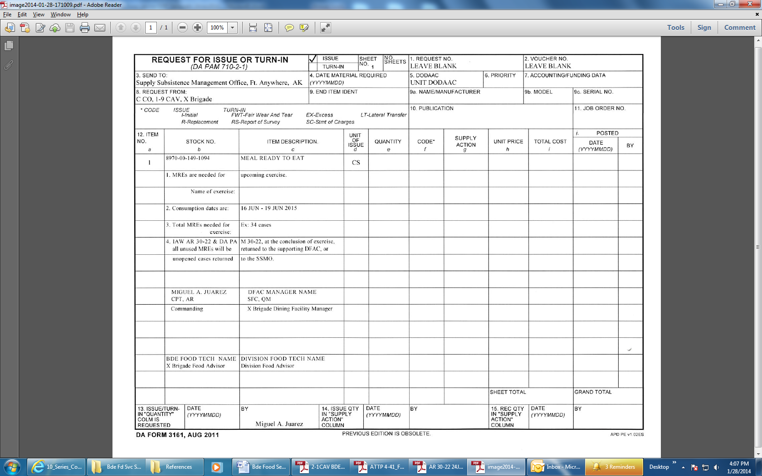

**Enclosure 3a:** Garrison Supported Field Feeding Format for Temporary Field Assignments

Department of the Army

ORGANIZATION

ORGANIZATION ADDRESS

**FORT ANYWHERE, STATE, ZIP**

OFFICE SYMBOL 7 January 2022

MEMORANDUM FOR RECORD

SUBJECT: Request Garrison Class I Support for _______________ Temporary Field Assignment (Gunnery, FTX, STX, etc*. more than 24 hours in duration*)

1. Nature of requirement: _______________.

2. Number of personnel requiring rations:

a. Meal Card Holders (SIK): ______.

b. Field Meal Cards (FAO): ______.

c. Total personnel: ______

3. Meals required and date(s) required:

a. Date(s) required: _______________

b. Hot A Meals

c. Warming/Cooling Beverages

DATE BREAKFAST LUNCH DINNER

XXMAR20XX A MRE A

4. Pick up information:

a. Pick up for meals and Warming/Cooling Beverages will be coordinated with the supporting DFAC Rations personnel.

(1) Breakfast meal pick up time: _______________

(2) Dinner meal pick up time: _______________

b. Rank and name of individual designated to pick up meals: _______________

c. Individual designated to pick up meals and Warming/Cooling Beverages must have a DD Form 577 signed by the unit Commander.

5. Local training that is 24 hours or less in length will not use the BAS recoupment process. If personnel attending the training are receiving BAS, their options are to pay for their government provided meals prior to training, or to provide their own subsistence during the training. Rations requests will include a by-name roster listing rank, name, meal card number or equivalent, and meal card type (SIK or FAO) for each Service Member consuming a meal See AR 30-22, 3-39, and DA PAM 30-22, 3-51 for additional guidance.

6. When signature headcount procedures are used and there is a deviation in excess of 10 percent between meals requested on this memorandum and the actual signature headcount, and meals sold for cash, an investigation will be conducted by the commander having operational control of the supporting dining facility (AR 30-22, para 3-39.*d.*). The investigation will determine if the dining facility account will suffer adversely due to the deviation between requested and actual meals consumed. If an adverse impact is determined, the commander having operational control of the DFAC will institute appropriate measure to relieve the adverse impact.

8. Point of contact for this memorandum is ____________________ at (799)___-_____ or email _______________.

GARY FLETCHER MIGUEL A. JUAREZ MARK STALLING RICHARD SMART

CPT, AG CPT, AR SFC, USA CW2, QM

S1 Adjutant Commanding DFAC Manager Bde Food Svc Tech

Encl:

DA Form 3161 (4 copies)

DD Form 577

DA Form 5913

SIK/FAO By-Name Roster

**Enclosure 3b:** Garrison Supported Field Feeding Format for Local Training Area Events

Department of the Army

ORGANIZATION

ORGANIZATION ADDRESS

**FORT ANYWHERE, STATE, ZIP**

OFFICE SYMBOL 7 January 2022

MEMORANDUM FOR RECORD

SUBJECT: Request Garrison Class I Support for _______________ Local Training Area Event (Ranges, Land Nav, etc*. less than 24 hours in duration*)

1. Nature of requirement: _______________.

2. Number of personnel requiring rations:

a. Meal Card Holders (SIK): ______.

b. Field Meal Cards (FAO): ______.

c. Total personnel: ______

3. Meals required and date(s) required:

a. Date(s) required: _______________

b. Hot A Meals

c. Warming/Cooling Beverages

DATE BREAKFAST LUNCH DINNER

XXMAR20XX A MRE A

4. Pick up information:

a. Pick up for meals and Warming/Cooling Beverages will be coordinated with the supporting DFAC Rations personnel.

(1) Breakfast meal pick up time: _______________

(2) Dinner meal pick up time: _______________

b. Rank and name of individual designated to pick up meals: _______________

c. Individual designated to pick up meals and Warming/Cooling Beverages must have a DD Form 577 signed by the unit Commander.

5. Temporary Field Assignment (TFA) training that is more than 24 hours but less than 180 days in length will use the BAS recoupment process for Soldiers receiving BAS. Officers consuming meals will be processed for payroll deduction. Rations requests will include a by-name roster listing rank, name, last four of the social security number, and either SIK or FAO for each SM consuming a meal.

6. When signature headcount procedures are used and there is a deviation in excess of 10 percent between meals requested on this memorandum and the actual signature headcount, and meals sold for cash, an investigation will be conducted by the commander having operational control of the supporting dining facility (AR 30-22, para 3-39.*d.*). The investigation will determine if the dining facility account will suffer adversely due to the deviation between requested and actual meals consumed. If an adverse impact is determined, the commander having operational control of the DFAC will institute appropriate measure to relieve the adverse impact.

7. Point of contact for this memorandum is ____________________ at (799)___-_____ or email _______________.

GARY FLETCHER MIGUEL A. JUAREZ MARK STALLING RICHARD SMART

CPT, AG CPT, AR SFC, USA CW2, QM

S1 Adjutant Commanding DFAC Manager Bde Food Svc Tech

Encl:

DA Form 3161 (4 copies)

DD Form 577

DA Form 5913

SIK/FAO By-Name Roster

**Enclosure 4:** Example DA Form 3032 One-Line Entry format

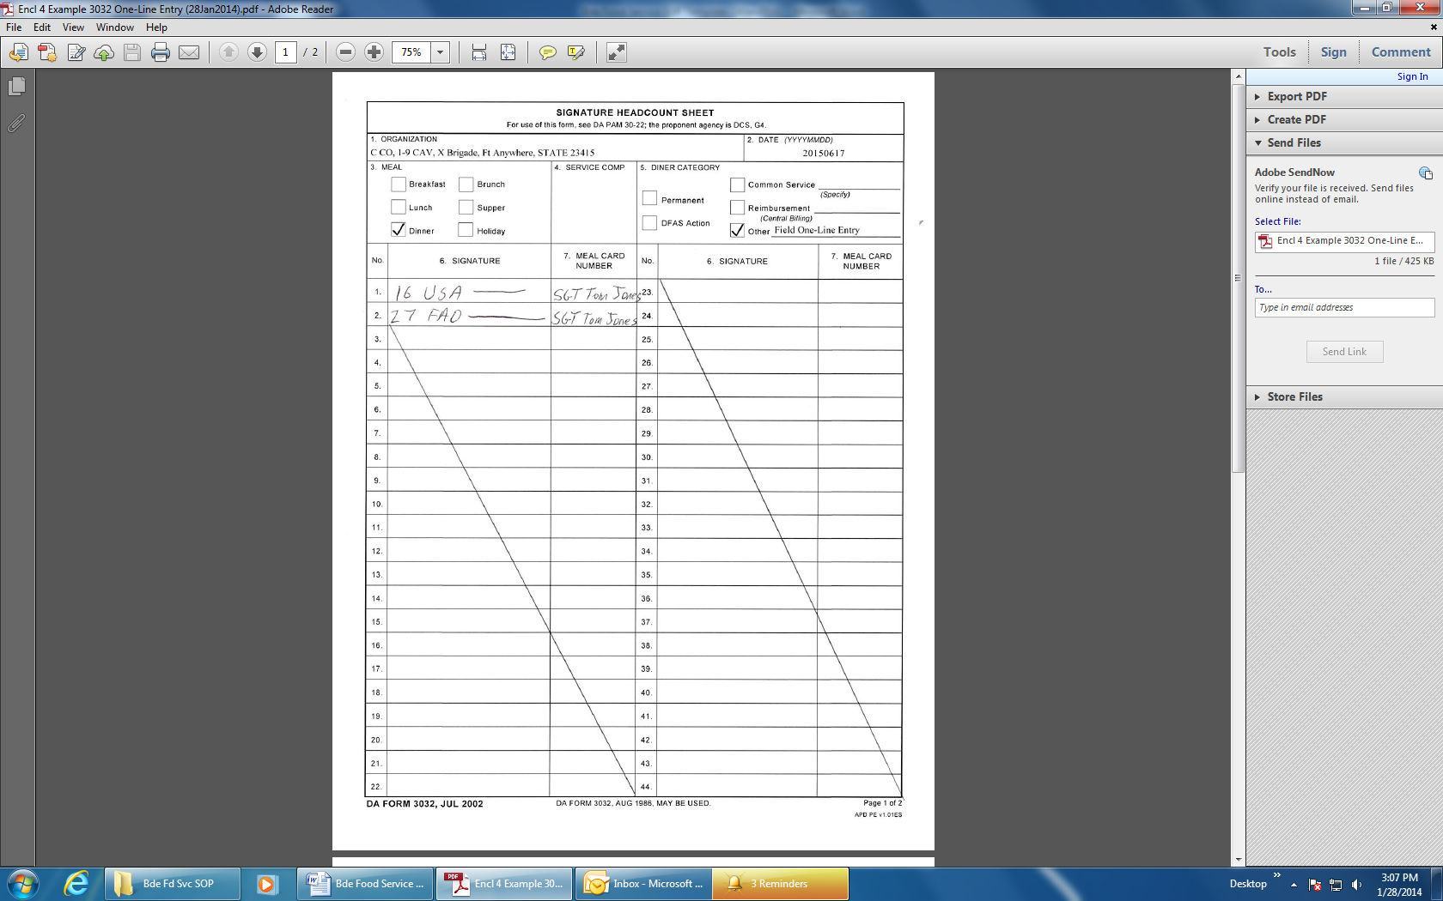

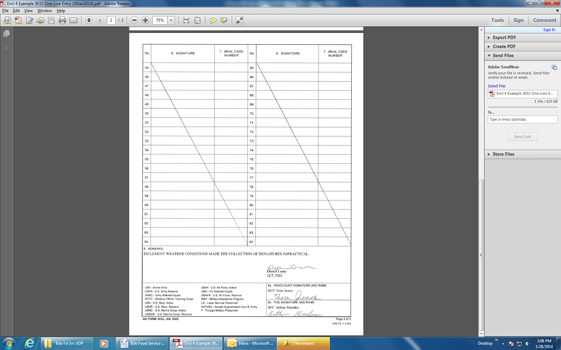

**Enclosure 5:** Field Feeding Account Memo

Department of the Army

ORGANIZATION

ORGANIZATION ADDRESS

**FORT ANYWHERE, STATE, ZIP**

OFFICE SYMBOL 7 January 2022

MEMORANDUM THRU

Commander, X Brigade, X Division, Attn: X Brigade Food Service, Fort Anywhere, State 12345

Commander, X Division, Attn: G4 Food Service, Fort Anywhere, State 12345

SUBJECT: Field Feeding Letter of Intent

1. Request Class I support for Field Training / Range / ETC. from 16 JUN to 19 JUN XX.
2. Number to support: Meal Card Holders (SIK) 16 (FAO) 27 Total: 43
3. Meals required:

Beginning Date/Meal: 16 JUN XX/Dinner Ending Date/Meal: 19 JUN XX/Breakfast

Rations type: A=UGR-A; M=Meals Ready-to-eat; BOX= Box Lunch; H&S= UGR H&S.

Day Breakfast Lunch Dinner

16 JUN XX BOX M H&S#14

17 JUN XX H&S#2 M UGR-A#1

18 JUN XX H&S#3 M UGR-A#2

19 JUN XX H&S#1 M UGR-AA#7

4. Pick up dates and times will be coordinated with the SSMO.

5. Any exceptions to the normal issue frequency (e.g. Request UGR-A Steak Meal for dinner 18 JUN XX).

6. Summer seasonal fruit is / is not requested.

7. The salad option is / is not requested.

8. Additional enhancements are / are not requested *(dry cereal, bread)*.

9. Temporary Field Assignment (TFA) training that is more than 24 hours but less than 180 days in length will use the BAS recoupment process for Soldiers receiving BAS. Officers consuming meals will be processed for payroll deduction. Rations requests will include a by-name roster listing rank, name, last four of the social security number, and either SIK or FAO for each SM consuming a meal.

10. This memorandum requires certification from the supporting PAC that BAS recoupment and/or payroll deduction (officers) will be submitted for personnel participating in the field training. This memorandum does not delete the requirement to submit a DA Form 5913-R (Strength and Feeder Report) to the DFAC.

11. When signature headcount procedures are used and there is a deviation in excess of 10 percent between meals requested on this memorandum and the actual signature headcount, and meals sold for cash, an investigation will be conducted by the commander having operational control of the supporting dining facility (AR 30-22, para 3-39.*d.*). The investigation will determine if the dining facility account will suffer adversely due to the deviation between requested and actual meals consumed. If an adverse impact is determined, the commander having operational control of the DFAC will institute appropriate measure to relieve the adverse impact.

12. Point of contact for this memorandum is ____________________ at (799) ___-_____ or email _______________.

GARY FLETCHER MIGUEL A. JUAREZ MARK STALLING RICHARD SMART

CPT, AG CPT, AR SFC, USA CW2, QM

S1 Adjutant Commanding DFAC Manager Bde Food Svc Tech

Encl:

DD Form 577

DA Form 5913

SIK/FAO By-Name Roster

**Enclosure 6:** Example ICE 3161

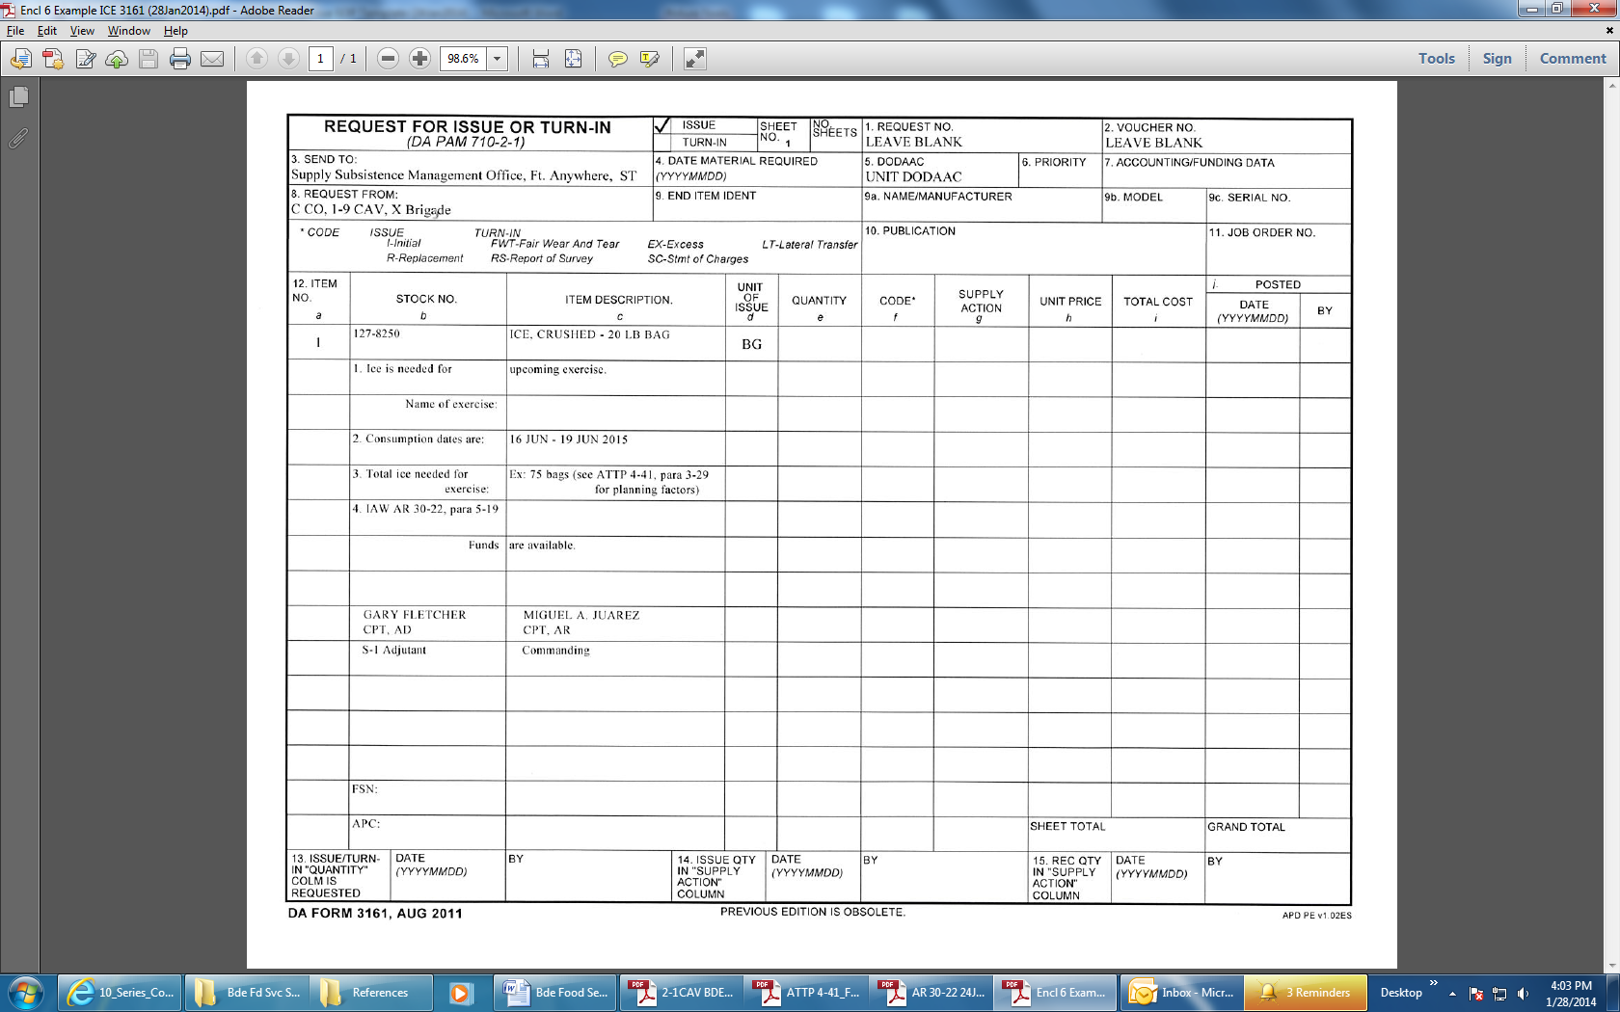

**Enclosure 7:** Organization Day Format

Department of the Army

ORGANIZATION

ORGANIZATION ADDRESS

**FORT ANYWHERE, STATE, ZIP**

OFFICE SYMBOL 7 January 2022

MEMORANDUM FOR X Brigade Dining Facility, ATTN: Dining Facility Manager

SUBJECT: Request Class I Support for Organizational Day Activities

1. C-CO, 1-9 CAV requests Class I support for Organization Day activities. Menu consists of the DFAC Organization Day Menu items.

2. Date/Time of Activities: 16 JUN 20XX / 0800 through 1700 hours.

3. Total Headcount: __________ Breakout of Personnel to be supported:

a. Officers: _______

b. Enlisted Receiving BAS: ______________

c. Family Members: ______________

d. Guests: ______________

e. Meal Cardholders (SIK): ______________

1. Pick up time: 1100 hours

5. Point of contact for this memorandum is ________________________________________ at 799-________ or email ___________.

6. When signature headcount procedures are used and there is a deviation in excess of 10 percent between meals requested on this memorandum and the actual signature headcount, and meals sold for cash, an investigation will be conducted by the commander having operational control of the supporting dining facility (AR 30-22, para 3-39.*d.*). The investigation will determine if the dining facility account will suffer adversely due to the deviation between requested and actual meals consumed. If an adverse impact is determined, the commander having operational control of the DFAC will institute appropriate measure to relieve the adverse impact.

7. Point of contact for this memorandum is ____________________ at (799) ___-_____ or email _______________.

MIGUEL A. JUAREZ MARK STALLING RICHARD SMART

CPT, AR SFC, USA CW2, QM

Commanding DFAC Manager Bde Food Svc Tech

Encl:

DD Form 577

SIK/FAO By-Name Roster

**Enclosure 8:** DFAC Organization Day Menu

Dining Facility Organization Day Menu

These items are available to units requesting meals for organization day. Amount of food items listed below will be based on headcount. For example, meats for a headcount of 400 will be divided by the 4 meats listed below (100 servings each).

Hamburgers

Hot Dogs

Ribs

Chicken

Potato salad

Relish tray

Baked Beans

Assorted condiments (salt, pepper, ketchup, mayo, mustard)

Assorted buns/breads

BBQ Sauce

Assort drinks (Kool-Aid, ice water, coffee)

The dining facility is not responsible for providing units with flatware, serving utensils, charcoal, lighter fluid, trash bags or ice. Ice can be locally purchased or request through the installation SSMO.

Units’ food service sections will provide the dining facility with insulated food containers, liquid dispensers IOT transport food items to unit’s function sites.

Meat items will be issued to the requesting unit pre-cooked.

Dining Facility Manager