ANNEX J

APPENDIX 1

Culinary Arts Competitive training event
Command Information Survey
Information provided will assist the PAO CI staff in telling Your Story and highlighting this competitive training event to media outlets.

Branch of Service: Choose an item. |  |  | Team/Individual: enter text.
First Name: Click here to enter text. |  |  |  |  | Last Name: enter text.
Rank (spell out): Choose an item. enter text. |  |  |  | Age: age |  | Time in Service:enter text.
Date of Rank:date. |  | MOS/Rating (Spell Out):enter text.
Current Unit of Assignment (Full Name and Location):Click here to enter text.

E-mail Address:Click here to enter text.
Have you been Deployed:  Yes __ No __ | When:Click here to enter text. |  |  |  | Where:Click here to enter text.
Hometown (City, State):Click here to enter text.
Is this your first culinary arts competitive training event? If not, how many times have you competed and when?Click here to enter text.

What does competing in the largest U.S. culinary competitive training event mean to you?Click here to enter text.

Why did you choose to become a military chef in your branch of service?Click here to enter text.

What is the most interesting part of being a culinary artist?Click here to enter text.

How important are food service professionals to the military? Why?Click here to enter text.

What do you think is the key to winning your specific event(s)? Why?Click here to enter text.

How did you prepare for this competitive training event (mentally and physically)?Click here to enter text.

Do you have any culinary influences (role models, styles)?Click here to enter text.

Do you have any culinary training aside from your military training? What is your culinary experience outside of the military?Click here to enter text.

What is your favorite meal to make? Why?Click here to enter text.

What is a chef’s most dependable utensil in the kitchen? Click here to enter text.

What is your favorite culinary memory?Click here to enter text.

Fort Lee Public Affairs Office, 1321 Battle Drive, Fort Lee, VA 23801

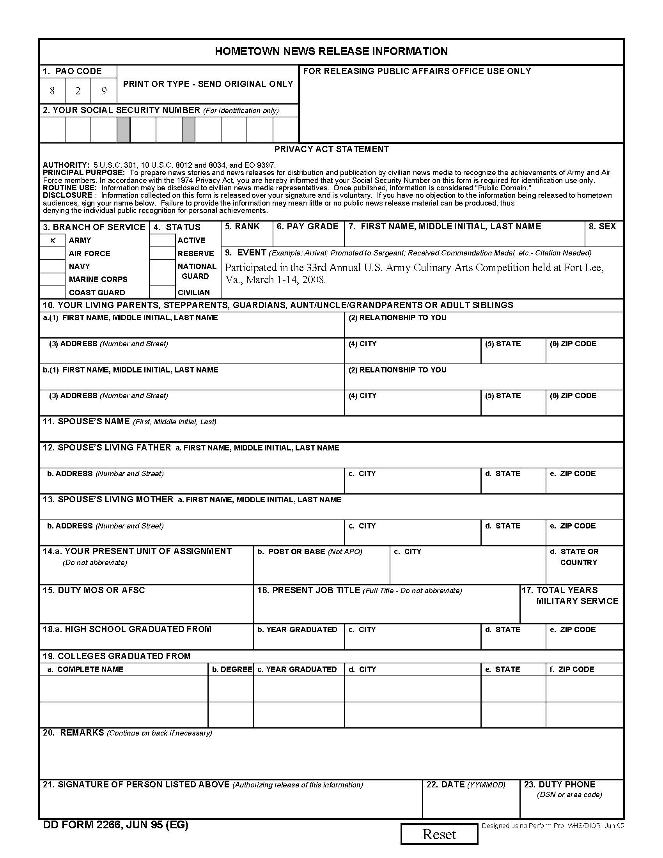
ANNEX J
APPENDIX 2

